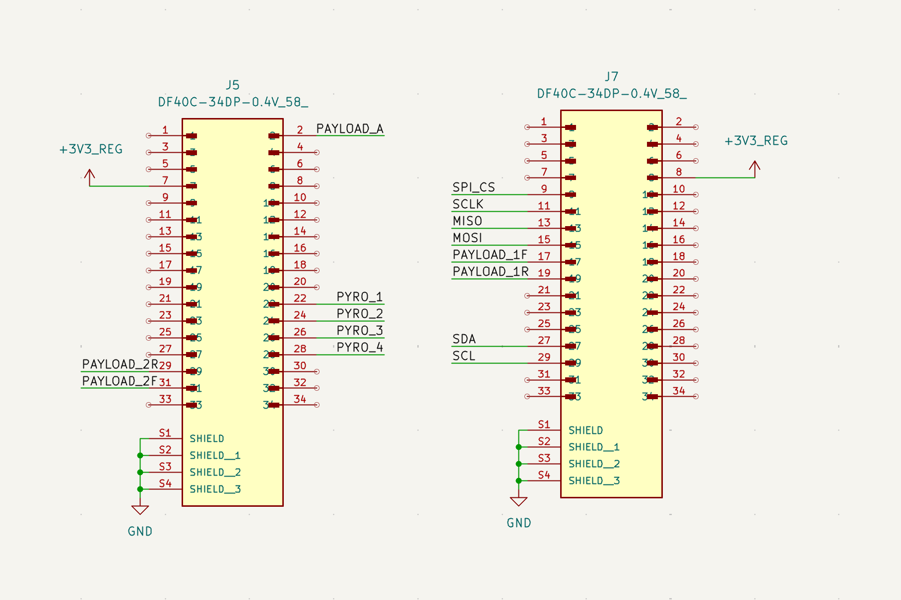
Page 1.

Same question as for the ACE file:
- Can S1-S4 be used as power/GND
- Check the current

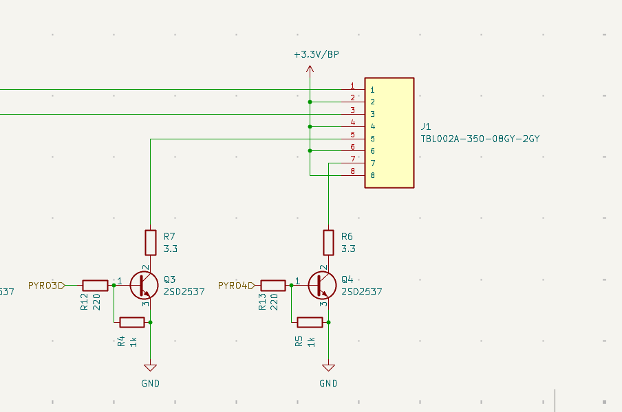
Page 2.

I don’t know the purpose of these four transistors. Do they work as switch or amplifier? I guess switch?
Please see below for my comments:
- Is PYRO1 a logic signal from page 1? If so, they have different names: PYRO_1 on Page 1. The same for PYRO2-4.
- Is 3V3 the 3V3_REG in the previous page?

Page 3
1. VBAT + Arming Switch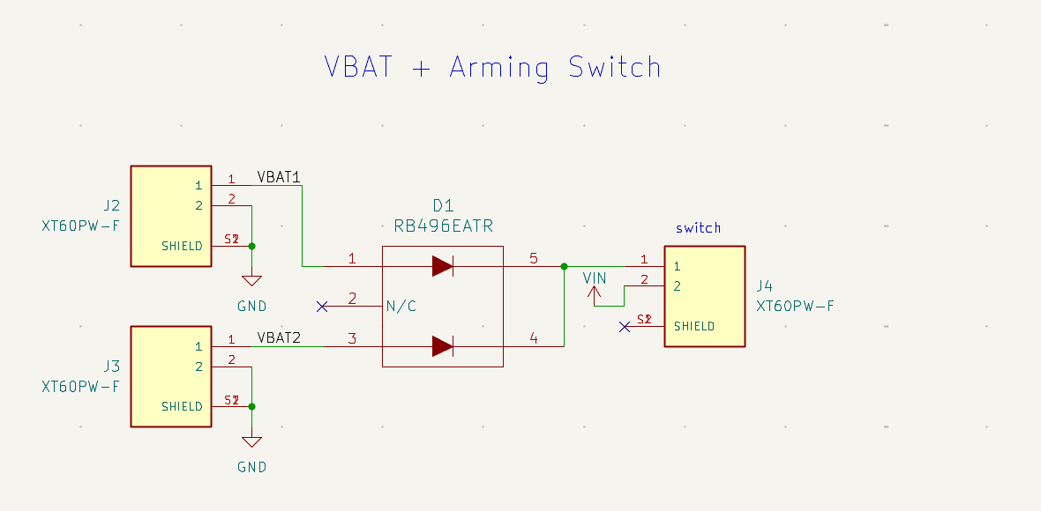
The same comments for the ACE file. Calculate the downstream current consumption, and reconsider the diode.

2. 3V3 Buck (U2)
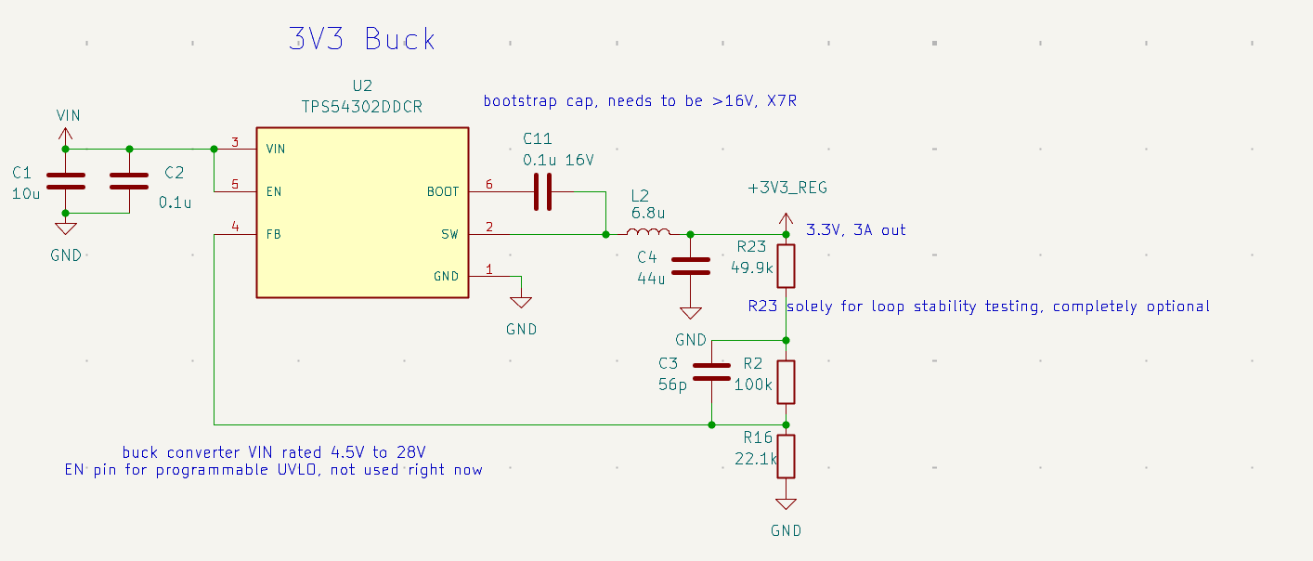
Below are my comments:
- R23 should be 49.9 ohms, not 49.9k, the same problem as in the ACE

